Rohini Shrivastava

IST 736

**Introduction:**

Movies are stories or event recorded by a camera to show moving pictures. The movie industry originated in the early 19th century. The first movie screening took place in Paris and was under a minute. It showed workers leaving a factory at the end of the working day. In America Hollywood started releasing multiple movies per year for audiences to watch. In Hollywood, the first movie created was Count of Monte Cristo in 1908. The first movies were in black and white and were silent films. The first color movie was Becky Sharp in 1935. Nowadays movies have become more technologically advanced using CGI, drones, and other 3D technology (History of Movies,2016).

A movie review describes the movie and gives criticism if there are any. It is based on the opinion of the watcher and allows future viewers to understand the details of the movie so they can determine if it is worth the time investment. These reviews not only impact the number of viewers for the movie itself, but also the production of these movies. The production costs of movies are so high, a review could cause the success or failure of a movie, causing a loss in earnings (ACME - DIGITAL CINEMA REVIEW, 2021). Any user can create a movie review. There are multiple sites, such as ‘Rotten Tomato’, ‘IMDB’, ‘Letterboxd’, that showcase audience reviews alongside critic reviews. Positive reviews can positively impact the number of viewers a movie is getting, increasing the box office revenue, whereas a negative review can do the opposite (Albert, 2007).

Netflix is a subscription based streaming platform that contains hundreds of movies and tv shows. Users pay a certain amount every month and have access to TV shows, movies, documentaries, and more on any internet connected device. They stream TV shows from multiple platforms and they also have their own production companies. The TV shows and movies Netflix creates are throughout multiple genres, but the focus today is on their Christmas movies, specifically ‘The Knight before Christmas’. Released just in time for the 2019 Christmas season, ‘The Knight Before Christmas’ is a romantic comedy that follows a medieval knight who is transported into present day America and falls in love with a high school teacher. It is a part of a group of movies that mainly features actress Vanessa Hudgens, also known as the VHCU (Vanessa Hudgens Cinematic Universe) (IMDB, 2019). It has been reviewed throughout different websites, but the focus will be on ‘Letterboxd’.

**Analysis:**

*About the Data:*

Movie reviews for “The Knight Before Christmas” were taken from Letterboxd. The reviews were sorted by number of stars. Three negative reviews were collected, each at ½ star, and three positive reviews were collected at 5 stars. The reviews collected had to be at least a paragraph long and not contain vulgar language (*Figure 1)*.

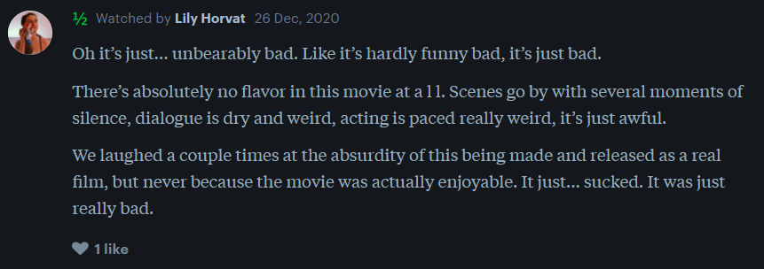

*Figure 1: Sample of Reviews Collected From Letterboxd*

The reviews were placed into a CSV file and any non-English characters were removed. Once the data had been cleaned, it was uploaded onto MTurk to be classified.

*MTurk:*

Amazon Mechanical Turk (MTurk) is a crowdsourced marketplace for businesses to outsource projects. It allows “Turkers”, or workers, to perform tasks virtually at their convenience.  The tasks all require human intelligence to complete. These Turkers help the requesters with data processing, analysis, and content moderation. The workers on MTurk go through each of the inputs and label the sentiment of the document (*Figure 2).* The workers are then paid out once their results have been approved. In the case of determining the sentiment of the movie reviews, the workers need to be proficient in English. The location and past work performance of the workers were not taken into consideration as this is determining whether a review is positive or negative. As the reviews are short and easy to determine, each answer is worth 10 cents. There was a time limit of 3 minutes for the entire task, and workers had two days to start.

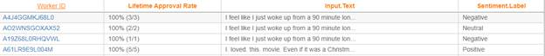

*Figure 2: Sample of Tasks Completed by Turkers*

To understand the similarity in data, the Kappa value was calculated. Cohen’s Kappa is a statistical measure of inter-agreement for categorical items. It looks at the decisions of different raters for categorizing the topic and removes the agreement of chance out of the equation. The review data was split into the sentiment for each of the workers for each review (*Figure 3).* To determine the Kappa value, the data is assuming a positive/neutral sentiment is a plus and a negative sentiment is a minus.

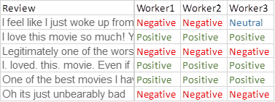

*Figure 3: Clean View of Sentiment for Review*

**RESULTS**

Three workers were found and completed all the tasks under two minutes. The overall payout for the workers was $2.60. There were no spammers found; all the answers, except one, were exactly the same. Collecting the data from the workers was quick and easy.

Workers 1 and Worker 2 both had the same exact answers for all the prompts. As such, their kappa value was 1 (*Figure 4)*. The only odd one out was Worker 3, who wrote neutral for input 1 instead of negative like the others. As Worker 1 and Worker 2 have the same decisions, the kappa value for them and Worker 3 was 0.6667 (*Figure 5).* The average kappa value between the three workers was 0.8333. Workers 1 and 2 had all the correct answers.

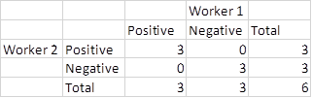

*Figure 4: Kappa Matrix for Worker 1 and 2*

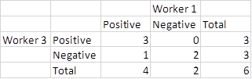

*Figure 5: Kappa Matrix for Worker 1 and 3*

**Conclusions:**

An equal amount of negative and positive reviews was collected and analyzed through MTurk. There were three workers that classified that data, and for the most part it was accurate. The third worker was the only one who had one different answer than expected. A high Kappa value was found for both. A high Kappa value indicates that the agreement may not have occurred through chance.

MTurk is a good tool for companies to use as it is very flexible for the type of work. Companies can ask workers to categorize, analyze, or moderate the content. The only downside is the costs associated with it. Companies can choose how much they want to pay, but if they pay too little most workers will not work on the project. If they are willing to payout higher then it may get too expensive. This could be hard to afford for smaller companies who do not have a high profit margin.

For movie companies, as interesting as using MTurk is, it does not make much sense. The reviews already come with a rating, whether it be as a percent or on a scale of 1- 5 stars. It would not make any sense for these companies to figure out the sentiment for the reviews their movies get. There are multiple websites that collect these reviews and give an overall rating. In the case of *The Knight Before Christmas* the reviews from ‘LetterBoxd’ averaged 2.3/5 stars, showing that the average sentiment was neutral/slightly negative.

**Bibliography:**

[Author removed at request of original publisher]. (2016, March 22). 8.2 the history of movies. Retrieved January 30, 2021, from <https://open.lib.umn.edu/mediaandculture/chapter/8-2-the-history-of-movies/>

ACME - DIGITAL CINEMA REVIEW. (n.d.). Retrieved January 31, 2021, from http://www.revue-acme.com/the-importance-of-a-film-review/

Albert, S., Austin, B., M.. Bagella, L., S.. Basuroy, S., R. M.. Baron, D., Baumann, S., . . . Zufryden, F. (1998, January 01). The impact of film reviews on the box office performance of art house versus mainstream motion pictures. Retrieved January 30, 2021, from https://link.springer.com/article/10.1007/s10824-006-9025-4

The Knight Before Christmas. (2019, November 21). Retrieved February 01, 2021, from https://www.imdb.com/title/tt10060094/